Hotel Management

Name :- Ratnesh Kumar Rajak
Er. No. :-161B168
Branch :- C.S.E
About The Project
The Project is about hotel management that how we cdan order our food in Hotel/Restaurant thorough an appplication for the the particular hotel /Restaurant.
When we run the project it will show the first screen that is all about the Name of Project ,submitter,and whom to submit it.
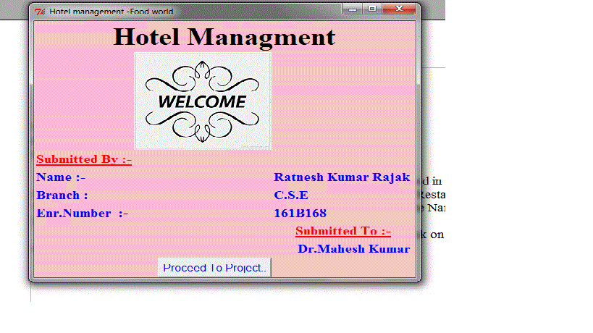
In the end of this screen there is a Button "Proceed to Project " click on it it will enter you in the project.
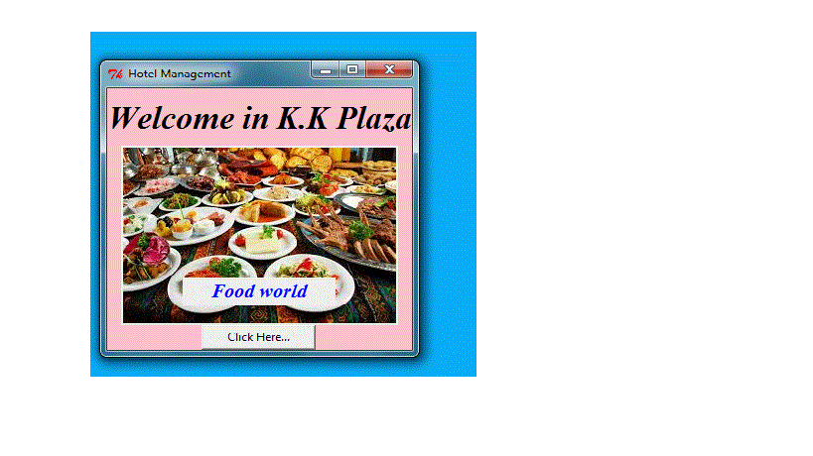
It will we look like this .when you click on the proceed to project second screen will appear. In the second screen it contains a gif image and a button "Click Here...".after clicking on it a dialog box will be open it will aks do you want to eat anything .then after there are three button will be appear "Yes","No",Cancle"if u click on "Yes " then the menu card will be appear on the screen . There are seven Button in that screen .
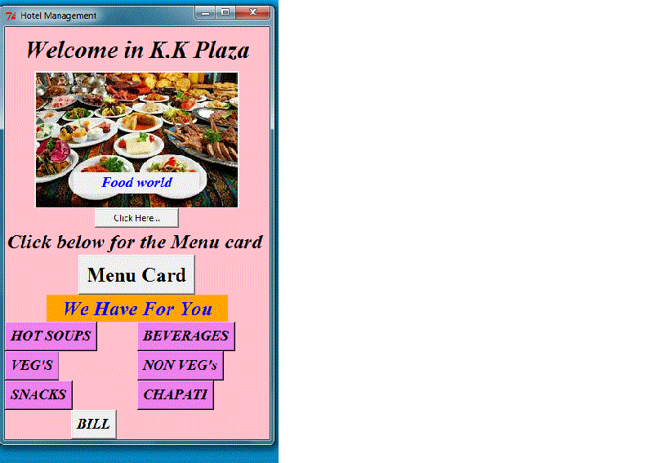
after clicking on any button a new window will be open and you can can order yor food and check how much bill we u have to give pay

and after ordiring everyb thing you have to press on the Button "Bill" it will give you the total payable ammount and greeting you .
And in second screen if u click on "No" then again a dialogbox will be open it will ask do u want to drink any thing if you clicl "Yes" then there are many check button will be appear on the screen ,order your wish drink and pay your bill. After click on "Bill" button it will show your bill and greet you
it's all about the project
Thanku...

